# JURUS 0 PERSIAPAN AMUNISI

Tahap persiapan pembuatan server web untuk laravel:

1. DOWNLOAD XAMPP SERVER

Klink link: <https://www.apachefriends.org/download.html>

Pilih 

1. Download composer

Klink link: <https://getcomposer.org/download/>

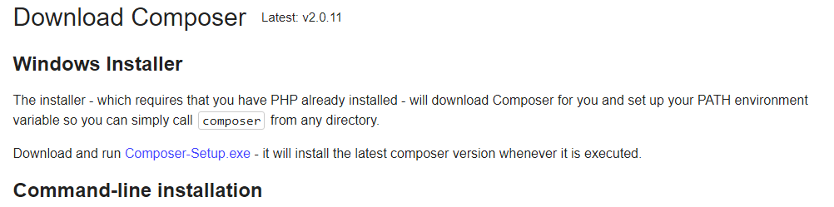klik download link composer-setup.exe

1. Install xampp
2. Install Composer